Name:_______________ Date:______________

Lesson 13 Adding and Subtracting Fractions and Mixed Numbers Notes

NEW CONCEPT

To **add mixed numbers**, the same rule as in adding fractions applies (find the LCD), but make sure that you always add the *whole numbers* to get your final answer.

**Example 1:** Add 2½ + 3¼.

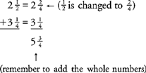

Sometimes, you may end up with a mixed number that includes an improper fraction. In that case, you must change the improper fraction to a mixed number and combine it with the sum of the integers.

**Example 2:** Add 2½ + 5¾.

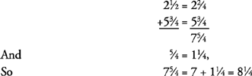

**Subtracting mixed numbers**

When you subtract mixed numbers, you sometimes may have to “borrow” from the whole number, just as you sometimes borrow from the next column when subtracting whole numbers. ***Note:*** When you borrow 1 from the whole number, the 1 must be changed to a fraction.

**Example 3:** Subtract

|  |  |  |
| --- | --- | --- |
| |  | | --- | |  | | fraction3.gif | |

Notice that you should borrow only after you have gotten a common denominator.

To subtract a mixed number from a whole number, you have to borrow from the whole number.

EXAMPLES

Subtract 6 − 31/5

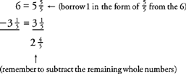

Name:_______________ Date:______________

Lesson Adding and Subtracting Fractions and Mixed Numbers Written Practice



1. 2. 3.

4.5.6**.**



7.8.9.



10.11.12.



13. 14. 15.



16. 17. 18.

